Local Debt Management in Ukraine: A Diagnostic Assessment
Prepared by Dr Milos Markovic, Senior NKE for Debt Management

Table of Contents
1. Introduction 4
2. Legal Framework surrounding SNG debt issues 5
2.1. The Budget Code (existing version) 6
Considerations and Recommendations 8
2.2. Legislative changes in circulation 13
3. Relevant business processes discussion 17
Considerations and Recommendations 19
4. SNG debt portfolio overview 21
Considerations and Recommendations 25
5. Public Debt at the SNG Level – functional considerations 28
5.1. Human resources 28
Considerations and recommendations 28
5.2. Risk management 29
Considerations and recommendations 30
5.3. Local debt management information system 31
Considerations and recommendations 32
6. Conclusions and further actions 34
ANNEX 1 36
ANNEX 2 38
ANNEX 3 40

List of tables

Figure 1. Overall illustration of the subnational government structure in Ukraine 4
Figure 2. Overall structure of the local governments’ debt portfolio 20
Figure 3. Direct liabilities of local governments, by creditor 21
Figure 4. Currency structure of local governments debt 22
Figure 5. Local government guarantees, by creditor 23
Figure 6. Share of local government debt in the general government debt, end of 2017 24
Figure 7. General government investment (left), Ukraine and peer countries (percentage of GDP) and structure of general government investment activity by segment (right) 25
Figure 8. Overview of SNG module of DMIS – key components 30
List of boxes
Box 1. Approaches to setting limits on SNG debt levels 9
Box 2. SNG debt limits in peer European countries 10

Introduction
Following the crisis breakout after Euromaidan and significant output shocks in 2015, Ukraine has recently entered a period of relative fiscal and overall economic stability with growth rates of 2.3 and 2.1 percent in 2016 and 2017. At the same time, inflation is approaching single digits while current account balance is only slightly negative helping stabilize the foreign exchange market along with strong financial support coming from the IMF. Public debt is growing to around 90 percent of GDP but mainly due to financial sector support and depreciation pressures. Finally, the fiscal balance is kept in the single negative digits reaching -3 percent at the end of 2017.
The awareness of the necessity to undertake deep structural reforms in order to make the economy more efficient to ensure sustainable growth became a political mainstream in past few years. It is against the backdrop of such ambition that Ukraine has recently adopted a very bold and elaborative Public Finance Management Strategy for the 2017-2021 period. At the same time, decentralization became a top reform priority of the Government. The reform includes the shift of fiscal responsibilities to local governments which is adequately being followed by decentralization of the delivery of key public services such as education, health and social welfare.
This report has been prepared as the kick-off activity within Component 3 of the EU Project titled “EU for Stronger Public Finance Systems of Local Governments”. The report stretches across all four activities under the component but mainly corresponds to the activity 3.1 which calls for a comprehensive review of current practices in debt management at local level in order to inform specific actions under the remaining three activities (i.e. 3.2., 3.3. and 3.4.). The project is aimed at achieving more reliable and efficient public financial management in Ukrainian local governments, while the primary objective of this particular project component is to support the MoF and local governments in developing and implementing a comprehensive strategy to revise methods for borrowing and debt management at the local government level. The assignment was carried out in three two-week missions during which the Team met with all relevant counterparts. The team met with representatives of the MoF and Treasury Department on many occasions (see Annex 3 for the full list of persons met).
This project activity is implemented during the inception phase and is meant to inform further project activities by setting analytical base for further actions in the domain of legislative changes related to debt management at the local level, modification and optimization of the corresponding business processes and procedural acts, human resources issues, risk management practice and finally local debt management information system. The structure of is as follows: Section 2 outlines the legal framework related to sub-national borrowing, Section 3 discusses the business processes behind debt and guarantees approval, Section 4 offers a review of local governments debt and guarantees portfolio, Section 5 presents the key functional aspects of the local debt management from the central level – HR, risk management and local governments debt management information system. All sections end with discussion on key challenges and recommendations for improvement. Finally, Section 6 concludes and offers a list of further actions linked to the already defined project activities within the Component 3.

Legal Framework surrounding SNG debt issues
According to the Constitution of Ukraine, the subnational government structure contains three layers. The first layer consists of 27 units including: 24 provinces (i.e. oblasts), the Autonomous Republic of Crimea and two cities with special status – Kiev and Sebastopol. The second layer encompasses 490 districts (i.e. raions) and another 182 cities within provinces (i.e. oblasts) districts which are assigned “oblast” significance. Finally, the third layer is composed of 278 towns of “raion” significance and around 11,000 village councils within different districts that incorporate around 28,000 different villages and rural settlements.
Figure 1. Overall illustration of the subnational government structure in Ukraine
The inventory of relevant legislative pieces that relate to public debt and guarantees at the SNG level in Ukraine, includes the following items:
- Budget Code of Ukraine
- Government Order on Approval of Local Borrowings (Order number 110)
- Government Order on Approval of Local Guarantees (Order number 541)
- Government Order on Control Over the Risks Associated with the Management of the State (Local) Debt (Order number 815)
- Ministerial Order on the Forms of Data Submission for Local Borrowings (Order number 922 – supplementing Government Order number 110)
- Ministerial Order on the Forms of Data Submission for Local Guarantees (Order number 921 – supplementing Government Order number 541)
In the coming section we will discuss the relevant parts of these regulations, present potential modifications which are presently in circulation and offer some additional changes that we consider would be worth implementing by Ukrainian authorities.

The Budget Code (existing version)
Hereby we will present the key provisions within the articles of the Budget Code of Ukraine which relate to management of debt and guarantees at the local level.
Budget Code, Article 16 - Issuing local debt
The issue of the authority to issue both internal and external debt is outlined in the Article 16 of the Budget Code. According the lines of the article, both internal and external debt can be issued by the Autonomous Republic of Crimea, cities with special status (i.e. Kiev and Sebastopol) and the cities with “oblast” significance. Cities with “raion” significance can issue internal debt obligations, but in terms of external debt they are limited to take it from international financial institutions (IFIs) only. The cities with “raion” significance are the lowest level of SNG that can issue debt. The process of decentralization, specifically the Law on Voluntary Amalgamation of Hromadas, stipulates that if a town of “raion” significance gathers several other smaller territorial units around it, it could achieve the status of a city with “oblast” significance which will expand its possibilities of taking external debt to creditors other than from IFIs. The authority to borrow given to these entities is on one hand grounded in the public property ownership framework of Ukraine, and on the other in the fiscal capacity breakdown among different layers of SNG (i.e. the relationship between different layers of sub-national budget in terms of the size of their budgets). Official data shows that in 2016, almost two thirds (i.e. 65 percent) of the total expenditure at the sub-national level came from the second layer – including districts (i.e. raions) and the cities with “oblast” significance.
This article further contains several relatively standard provisions related to the process of servicing local debt as well as procedures for modifying local budgets in cases where initially allocated funds turn insufficient to cover the running debt-related obligations (i.e. interest and principal payments). Part 8 of the article allows for temporary excess liquidity of local governments to be used to purchase securities or be placed in commercial banks as deposits on a competitive basis.
Budget Code, Article 17 – Issuing local guarantees
This article sets forth the key issues around the process of issuing guarantees from SNGs to local business entities. Similar to the debt origination, guarantees may be extended by the Autonomous Republic of Crimea, cities with special status (i.e. Kiev and Sebastopol) and the cities with “oblast” significance. The approved areas in which these businesses operate include housing and utility while the projects for guarantees may be issued include those that aim at development of municipal infrastructure or implementation of resource-saving technology.
As underlined here, the mandatory condition for issuing a local guarantee is conclusion of an agreement between the relevant local financial body and the economic entity which must contain provisions regulating compensation of the local authorities by the obligor (i.e. business entity) in case servicing of the guarantee is made at the expense of the SNG. A feature of the article worth noticing is that according to it, the SNGs are allowed to sell off their receivables from the obligor to a third party. Finally, writing off debts of business entities to SNGs which come about as a consequence of activating the guarantee, is prohibited unless such entity is officially deemed bankrupt. In this case provisions of a separate Government Order apply.
Budget Code, Article 18 – Debt and guarantees related ceilings
This article contains provisions which set strict quantitative limits over the level of debt and guarantees of a SNG as well as their annual debt and guarantee servicing outlays. According to it, the combined value of outstanding public debt and guarantees may not exceed 200 percent of the projected average annual value of the special funds budget for the next two years. The projected special funds budget should exclude the inflows from borrowing and transfers. In case of the city of Kiev this limit is increased to the level of 400 percent. Temporary breach of this limit is allowed but prior consent of the city council is required.
Budget Code, Article 74 – Other important aspects
This article is multifold and it serves the purpose of defining other important aspects of loan and guarantees business at the SNG level not covered by the previous relevant articles, specifically:
- It defines the purpose of loans taken by SNGs as that which should “create, add to or renew strategic objects of long-term use” or those that contribute to enhanced public service delivery.
- It stipulates that terms and conditions of borrowing made at SNG level should be agreed with MoF. This provision essentially asks for approval of loan terms and conditions my MoF performed by reviewing loan application submitted by SNGs.
- It defines explicitly that the government should not be held liable for debt of any SNG.
- Financing of local debt (i.e. interest and principal payments) should be made out of the general funds budget of SNGs.
- The article contains provisions which set the penalty for those SNGs which breach their obligation to repay to be a five-year ban on taking new borrowing
- Finally, this article contains another important limit related to public debt at local level. This is the limit which grounds the total amount of debt servicing (i.e. interest and principal payments) to 10 percent of the general funds expenditure in the budget period (i.e. year) when the servicing of debt is planned. It also stipulates that servicing should be made out of the general funds budget of SNGs.

Considerations and Recommendations
- Debt limits provisions
Currently the Budget Code prescribes two different types of debt and indirect debt (i.e. guarantees) related limits. The first one is that their combined value should not exceed 200 percent of projected average value of the special (i.e. development) fund budget for the next two years. Another limit refers to the value of debt servicing expenditure which should not exceed 10 percent of general funds budget (i.e. operating revenues). Box 1 below outlines the general approaches to setting the debt-related limts at the SNG level.
Box 1. Approaches to setting limits on SNG debt levels
According to Ter-Minassian & Craig (1997), there are four possible approaches to setting the limits on public debt of SNGs:
- Reliance on market discipline
This is a laissez-faire approach where SNG may borrow as they wish with no bailout possibility from the central government. A primary pre-condition here is a solid base of own tax revenues of an SNG.
- Cooperative approach
Here, all levels of government work together to achieve common fiscal targets and debt service amounts and its levels at SNGs are rather flexible and represent one of the instruments to attain these goals. There is again much independence of SNG in determining the level of their debts and freedom related to legal terms of these arrangements.
- Rules-based approach
Here, the level of debt and debt service is determined by a specific ratio linked to an available fiscal indicator (e.g. revenues, general government public debt). These rules may be universal or formulated differently for various groups of SNGs based on different criteria (e.g. development level) or tailored specifically for each individual SNG based on its fiscal capacity and credit history.
- Administrative controls
This approach includes strict regulatory limits over not only debt levels and servicing amounts, but also on the type of debt that can be taken (i.e. external vs internal), exclusion of certain SNGs from the market, or even centralization of the system of SNG borrowing.

As we can see, the world of potential approaches includes those that range from a completely liberalized ones to those where SNG borrowing is bound by administrative rules and completely centralized. Ukraine, as most of the other European countries applies a modified version of this rules-based approach combined with the administrative approach.

Box 2. below offers the criteria for SNG debt levels and servicing expenditures applied by central governments of Poland, Croatia and Serbia. This group of countries was selected based on the fact that they share somewhat similar pre-1990 background as Ukraine and the differences in European integration process – Poland as a relatively seasoned EU member, Croatia as a new EU member and Serbia as a country with candidate status which is well into its accession negotiations with the EU.
Box 2. SNG debt limits in peer European countries
Poland
Currently, Poland applies a debt related rule where debt levels are estimated separately for each unit of SNG while debt servicing level of an SNG cannot exceed past three-years’ average of the combined value of its operating surplus (excess of operating revenues over operating expenditure) and proceeds from the sale of assets. Previously, its debt service limit was at 15 percent of total revenues while debt levels were not supposed to exceed 60 percent of last year’s revenues. (Galinski, 2015)
Croatia
Debt servicing limit is established at the level of 20 percent of the previous year’s revenues excluding donations, certain types of voluntary transfers from the central government and other extraordinary revenues. There is no explicit limit on the total debt of an SNG. The Budget Law of Croatia defines what may be the total new debt issued by all SNGs in a year (i.e. in 2018 it is determined at 3 percent of total operating revenues of all SNG in 2017) and approvals are granted on a first-come first-served basis. (Bajo and Primorac, 2010; Budget Law of Croatia for 2018)
Serbia
Total public debt of an SNG in Serbia is limited to 50 percent of operating revenues from the previous year. Simultaneously, the total value of debt principal and interest repayment is set at 15 percent of operating revenues in the previous year. (Public Debt Law of Serbia)

While Ukraine, as most of other European countries, applies the restriction on local debt purpose which can be used for capital projects only implying existence of the fiscal golden-rule (i.e. operating expenses cannot go beyond operating revenues), it is also basing its debt servicing limit on operating revenues. Although further examination may be required as to whether 10 percent limit can be modified upwards to allow for more development potential of SNGs, its structure can be deemed appropriate. Applying strict controls over this limit which is essentially a liquidity indicator, implicitly allows the central government to control for debt levels which is a solvency indicator. It is able to do so through the control of certain elements of loan terms – above all maturity and repayment frequency. Ultimately, this allows governments to gradually lose up or completely abolish total debt limits applied to individual SNGs.
Although theoretically redundant, strict implementation of the debt level limit is required to control for lack of fiscal independence and stability at sub-national level. However, there are several obvious drawbacks in the way the overall debt limit in case of Ukraine is formulated. First of all, as opposed to the selected group of peer countries, it refers to the special funds (i.e. development) budget which is financed primarily by the proceeds from sale of land and property and potential budget surpluses from previous years. This makes it very volatile and difficult to estimate. Also, there is a strong incentive of SNGs to overestimate their development budget to reach over the limits imposed by the BC. Although the Local Budget’s Department of the MoF (LBD) who is in charge of processing loan and guarantees application tries its best to prevent and correct for unrealistic forecasts of special (i.e. development) fund budget, it is virtually impossible to have a deep enough insight into each of the individual SNG position to be able to credibly judge their estimates. Another issue is that these limits apply not only during a loan application process but also after a loan is taken. Since it is very difficult to expect the special fund to be stable from year to year because of the source of its financing, an SNG may come to a situation that it breaches the limit while its debt levels are stable or even being reduced due to repayments of principal. Finally, if the intention of the lawmaker was to tie the debt level to the special funds volume in order to control for its level given that the purpose of public debt is to finance investment projects, then one must consider again the variability of the special funds budget in this sense. Also, it must be noted that the it is very explicitly outlined in Article 16 of the BC that issuing debt must serve the purpose of enhancing local infrastructure (i.e. development). This purpose is controlled very strictly by the LBD during the loan application phase and should be additionally examined within the external audit process.
All that said, it might be worth considering for Ukrainian authorities to modify this rule to enable more effective borrowing and exertion of the control and monitoring function by the MoF (i.e. LBD). Our recommendation in this sense would go towards application of SNG debt level limit which would refer to operating revenues (i.e. the general budget), rather than on the special funds budget. Also, the debt level limit should be based on realized (i.e. past) rather than expected (i.e. projected) fiscal aggregates. Such rule is applied by most of the European countries.
- Provisions regarding penalty for SNGs failing to meet their obligations
Whether the financial obligations of an SNG can be transferred to the central government budget or not, SNGs failure to meet financial obligations can implicitly hurt the credit rating of the country. This is why central governments usually engage in developing different pre-cautionary legislative provisions to protect their reputation and ensure smooth service delivery at all government levels. Currently, the provisions which protect the Ukrainian central government from financial failure of SNGs may be considered too strict – for several reasons. One is that such provisions are not “proactive” in the sense that they prescribe actions only after a particular SNGs has missed their debt payment. This is a situation when damage is already done while central government should act to prevent it. One of the obvious ways to do is to introduce and implement strict criteria on taking new borrowing while being able to perform accurate and credible assessment of SNGs creditworthiness (i.e. capacity to repay their obligations). Another reason is that the penalty itself which includes a ban from financial markets for a term of five years effectively prevents the SNG to grow its way out of the financial difficulties. This is done through blocking an important source of financing (i.e. apart from its own funds) to develop its infrastructure and boost economic activity on its territory which eventually reflects on its income statement through increased revenues from different types of taxes. One of the measures authorities may consider is the option of introducing a possibility to temporarily halt or decrease transfers flowing to a particular SNG in cases when it fails to meet its debt servicing obligations and using these reductions to service the debt of such SNGs. An obvious candidate for this is the “stabilization grant” which is the only one within the current transfer system that is not directly tied to service delivery at sub-national level.

Legislative changes in circulation
At the moment, there are few versions of very comprehensive changes to the Budget Code provisions that relate to public debt at local level. Below we present and discuss these changes and show how they relate to the BC version which is currently in effect.
- In the Parliament
Within this proposition, there are quite a few proposed changes to the articles of the Budget Code that relate to debt of SNGs.
First, the limits regarding debt level and service are moved to the annex of the annual Budget Law which seems like a reasonable move allowing for more flexibility with this regard. However, if this flexibility option is too often exercised and debt related limits are often changed it may be interpreted as a bad signal by the investment community which tends to value stability and confidence.
Second, these changes introduce the notion of Debt Management Strategy (DMS) in the article dealing with both central government and local borrowing process (i.e. Article 16). While this is considered a relatively standard feature of similar legislative pieces, it remains unclear whether the it should and to which extent concern SNGs.
Third, the level and specifics around government guarantees to be issued in a particular year are to be specified in the annual Budget Law. As for the above paragraph regarding the DMS, it is unclear whether SNGs should also specify their intended guarantees in their respective budget decisions.
Fourth, there are proposed provisions obviously aiming to protect the integrity of the country’s profile on financial markets. One of them envisages that in cases when a business entity which is granted a guarantee on a portion of its loan fails to make its payments to the SNGs, the collecting agency should collect the entire amount of the guarantee and settle the business entity’s obligations to both the creditor and the SNG. Another proposed provision explicitly prohibits SNGs to grant additional guarantees to those business entities that have outstanding financial obligations resulting from earlier guarantees, debt or any other obligations to the budgetary authority.
Fifth, there are proposed modifications to the article 18 which defines the overall limit of debt incurred by SNGs. However, this proposition does not interfere with technical aspects of the limit calculation, but rather relates the key parameter of this ratio – the projected amount of the development budget of an SNG, to the article which defines the how the financial plans of SNGs should be developed within the medium-term budget framework which is being introduced by this updated version of the BC.
Finally, and addition to the existing article 73. envisages possibility of the central government to pass on a loan to an SNG entity in case of joint investment projects financed by an international financial organization or a foreign credit institution.
- Informal changes prepared by MoF
Since the beginning of the year there have been many informal drafts of possible changes to the public debt related provisions of the Budget Code prepared by relevant departments within the MoF – the Department for Municipal Budgets and the Debt Management Policy Department. The draft that is currently in circulation and which was submitted to the Team during July envisages changes to Articles 2, 12, 16, 17, 18, 67, 72 and 74 of the Budget Code.
Most of the proposed changes relate to inclusion of Amalgamated Hromadas as a legitimate SNG level which can take on debt and issue guarantees. The proposed changes are very much standard and are included within Articles 2, 12, 16, 17, 18 and 74. Although alignment of the Budget Code with the Law on Voluntary Amalgamation of Hromadas is obviously necessary, issues may arise with a sudden inclusion of these new territorial units into the public debt and guarantees system having in mind their capacities – both human and financial to carry out this process. It is thus advisable to consider postponing their complete inclusion for several years until the process of amalgamation is over, or better set a limit for a newly formed Hromada to be out of the capital market for certain number of years until it is consolidated and fully functioning.
Another important block of changes here is the one related to debt servicing limits. The first one relates to provisions of the Article 18 (paragraph 3) which defines the overall debt limit. Changes envisage that the limit should be set as 60 percent of the previous year general fund revenues. This solution is far more reliable from the implementation and monitoring perspective for reasons discussed above. Among many, the primary reason for turning to the past instead of the future revenues is the subjectivity and uncertainty around building projections while using special funds instead of the general funds adds to the magnitude of this drawback.
The second one relates to the debt servicing limit which is proposed to be set in accordance with the following formula:
(К_{n}+О_{n}+G_{n}) < =1/3*(Dz_{n-1}-Vz _{n-1}+ Dz_{n-2}-Vz _{n-2 +} Dz_{n-3}-Vz _{n-3})
Dz_{n} Dz_{n-1} Dz_{n-2} Dz_{n-3}

Where, Kn, On and Gn represent debt servicing outflows (principal, interest and guarantees) while Dz and Vz are general fund revenues and expenditure net of central government transfers.
There are certain issues with this approach which are worth stressing. One is very practical and relates to the SNGs with no debt who want to pursue debt origination to finance a capital project. In order to be able to finance their installments in current year, they would have had to finish last three years with budget surpluses which are on average sufficient enough to cover for that. This, in effect, means that an SNG would have to plan three years ahead in order to raise its first debt. This is particularly applicable to Ukraine where over 90 percent of SNGs do not have debt (i.e. out of those which are allowed to take it). Another reason relates to the collision with the Article 72 of the Budget Code which explicitly sets the cases when an SNG budget can be approved with deficit or surplus and what are legitimate purposes for utilization of such surplus and none of them includes debt servicing. Since, effectively, the surplus even if there was any will not be used for servicing debt, there is no reason to tie debt servicing with existence of a budget surplus. It is thus advised that debt servicing limit remains linked to the general funds revenues. Whether it should remain at the level of, rather conservative, 10 percent or be brought up is a subject for discussion and further investigation. Finally, since the debt servicing limit is now included in Article 18 as a new paragraph, the provisions of the Article 74 (paragraph 6) defining the limits in the existing version of the BC are proposed to be deleted.
Finally, the in the paragraph 7 of the Article 74 there are proposed changes which clarify the circumstances around exclusion of certain SNG from the capital market. In the old version there was a provision that an SNG should be excluded if its late on any of its debt related payments, while the new version foresees that the cut-off date for application of this penalty should be the end of the year. Although there is a room for translation misunderstandings, our reading of these changes is that they are more flexible than the previous ones since they allow the unpaid debt obligations to be carried out until the end of the year. Although the envisaged penalty of five-year exclusion from the capital market can be deemed too restrictive, the proposed changes should be probably be reconsidered to discourage late debt payments by SNGs.
- Informal changes proposed by the association of cities
Legislative framework changes proposed by the Association of Ukrainian cities include not only those related to the Budget Code, but also the ones including the rest of the pieces regulating debt management at the SNG level. In general, they are aimed at providing more independence to SNGs in their debt operations.
One set of proposals can be grouped around the issue of cash management. Article 16 of the BC regulates this subject and outlines the purpose of use of excess liquidity of SNGs. The AUC is asking for foreign currency denominated balances to be explicitly allowed to be used for the purposes listed there in the context of cash management. This is generally appropriate, but the question is whether the BC currently prohibits this. In case that it doesn’t the change is not necessary. While in case that it does, the accompanying changes of the articles interfering with it should be proposed.
Another proposition worth discussing is the one related to liberalization of debt market for amounts of up to USD 1 million for IFIs’ supplied funds. Or in other words, allowing SNGs to take new debt of up to USD 1 million without the consent from the MoF. This idea seems attractive from several points of view. Above all, it will give a strong financial boost to the large cities with ready-to-finance projects. However, we strongly advise against this since there are SNGs with insufficient fiscal capacity which would be seriously hurt if several loans of just under USD 1 million would be taken within a short period. Also, there is always a possibility of working around these limits by taking few loans for the same or similar purpose while they would otherwise be tranches of a big loan which MoF would have to approve. This calls for additional monitoring efforts.
Finally, the third group of changes relate to the issue of debt restructuring. The AUC suggests that when a loan disbursement does not happen on a date indicated in the contract, that such cases should not be considered “debt restructuring” and thus exempt from the usual procedure in case of restructuring which can take significant time to complete. This is a rightful request given that the time lag is small. In cases when the time gone from the moment money was supposed to be disbursed until it is actually disbursed is large, the MoF should re-assess the financial capacity of the SNG. The AUC suggests that debt restructuring application should be equalized to debt application in the sense that it should be deemed approved if one month elapses from the time it is submitted to MoF. This could be reasonable in cases when restructuring is confused with some insignificant departure from the original borrowing plan, as in the case described above. However, it should not be broadened to include restructuring in traditional sense of the word, as restructuring usually comes as a consequence of financial difficulties of the borrower and enough time should be given to MoF to properly assess the new circumstances.

Relevant business processes discussion
The process of approving debt origination at the level of local governments (LGs) in Ukraine is primarily regulated by the Government Order number 110 brought in 2011. This Order is grounded in the last paragraph of the Article 74 of the Budget Code. Based on the article 6 of the Government Order 110 the Minister of Finance issued an Instruction number 922 which supplements the Order and prescribes detailed format of the information that needs to be submitted by the SNGs in the process.
The process of issuing new debt is officially managed by the Debt Policy Department while in practice it is administered by the Local Budgets Department of the Ministry of Finance. The illustration of the whole process is provided in the Annex to this report. The process starts with submission of loan application sent from an SNG to the Debt Policy Department of the MoF. There is no prescribed format of the application itself, but the accompanying documents are strictly specified by the Order 110. They are:
- Status of SNG debt portfolio. This item includes a snapshot of all borrowings together with their repayment status (separately for principal and interest payments) for five years preceding the year when application is made. It also includes the information on activated guarantees if any.
- Proof of fulfillment of debt related limits – the one on the overall debt as well as the one on debt servicing, according to Articles 18 and 74 of the BC.
- Decision of the City Council to approve loan application (i.e. The Decision on Borrowing) containing key information on the loan including its purpose and form of borrowing, as well as the financial elements such as: amount, currency, maturity, interest rate and repayment frequency.
- Budget decision of the City Council for the current year. The Order 110 stipulates that if borrowing which is applied for is not specified in the submitted budget decision, then the draft of the appropriate changes to the budget decision has to be submitted.
- Budgetary projections for the next two years. There is no prescribed format for the projections, except general principles laid out in the Article 21 of the BC. The projections have to be approved the executive body (i.e. government).
- Extract from last year’s budget execution report. The original budget execution report is sent by SNGs to the Treasury department while MoF needs abbreviated form of the Income Statement along with information on outstanding debt and issued guarantees.

The process of approving guarantees issuance is regulated by the Government Order number 541 brought in 2012. The Order is accompanied by the Instructions number 921 formulated by the Minister of Finance which are based on the Article 4 of the Order. The instructions prescribe the format for submission of data in the process of approval of issuing a guarantee by a SNG – point 1 and 2 below. As with debt origination, the whole process is nominally managed by the Debt Policy Department while in practice the guarantee application is processed by the Local Budgets Department. Again, the process starts with an application which is accompanied by almost identical set of documents. There are however few differences:
- Instead of the status of debt and guarantees portfolio for the previous five years, SNGs are required to submit projections of debt and guarantees related repayments for the period between the end of the current fiscal year until the last repayment is made on both debt and guarantees.
- Instead of providing a proof of fulfillment of both debt related limits, here, the SNGs are required to submit only the proof that they satisfied the limit related to total debt – as prescribed by the Article 18 of the BC.
- Finally, the SNGs are required to provide a narrative on justification of guarantee issuance containing specifically the elements such as: content, goals and objectives to be achieved by the particular project, the impact of the investment on the economic and social development of the city, estimated cost, terms of project implementation (i.e. scheduling), the amount of the underlying loan and justification for the source of repayment. There is no prescribed format in which SNGs submit this information.
As already noted, it is the Debt Policy Department which receives the initial set of documents accompanying both debt and guarantee issuance applications. The documents are then transferred to the Local Budgets Department which carries out the operational aspect of the process. The process is interactive, meaning that potential additional information is asked from SNGs if needed. The entire communication is taking place through physical mailing and partially through emails. At the end of the process, the analyst from the Local Budgets Department issues an “expert opinion” stating the reasons for approving or disapproving of the debt or guarantee application. This document is sent for review to the Debt Policy Department which prepares a draft Ministerial Order based on the expert opinion. Once the Order is signed by the Minister of Finance, it is sent to the SNG in question which is the official basis for signing the loan agreement. Once the loan agreement is signed it has to be ratified in the form of Decision of the City Council. The process ends when the Debt Policy department receives the signed loan agreement along with the ratification decision. The loan is then registered in the Debt Management Information System (DMIS).
After the loan is registered in the DMIS, the local governments are obliged to notify the MoF of any regular (e.g. disbursements, repayments) or irregular occurrences taking place during the life of the debt or guarantee within the period of 10 days.
The approval procedure (i.e. up to the point when the Ministerial Order has to be issued) lasts up to one month, pursuant to the point 7 or the Order number 110 (for debt application) and point 5 of the Order number 541 (for guarantees application). There is an exception to this rule which applies to cases when the creditors are IFIs. In this case, the application is considered approved if the MoF does not issue the Order in one month.

Considerations and Recommendations
The process of debt and guarantees issuance approval is generally well structured and straight-forward. It is sufficiently backed up by proper regulation while most data-intensive exchanges within the process take place through prescribed formats. At the time of drafting this report, we were in possession of the draft legislation changes regarding debt and guarantees at the local level prepared by the UAC which could be in fact considered as a summary of “customer” (in this case cities) review. Except for the changes already discussed above, none of them dealt with the application process itself. This of course does not necessarily imply that all cities are completely satisfied with it, but does indicate that MoF is at least broadly on the right track with the existing structure of both business processes.
However, there is certain room for improvement to make the processes more efficient. The actions that MoF should consider to implement in the medium-term include mainly those related to automatization of data exchange.
Debt and guarantees related data submitted during the process can be grouped into those related to the past and those related to the future (i.e. projections). While projections do have to be developed by the SNGs themselves, the data from the past seems to be almost entirely in possession of different parts of the MoF already. For instance, the corresponding Government Orders prescribe the obligation of SNGs to notify the Debt Policy Department of any changes during the life of a loan or guarantee (i.e. disbursements, repayments, interest rate change, etc) within 10 days. Debt Policy Department enters this information in the DMIS as it comes. Since both Orders are in place from at least 2012, this means that MoF should ideally have accurate records for at least 5 to 6 years in the past. Although it has to be examined thoroughly, in practice this could mean that submission of the data related to debt and guarantees items for the past 5 years within the loan application process (i.e. item number 1) can be considered redundant because MoF already has the records so it could extract and assess it as required.
Further, both processes require submission of budget execution data in order for an SNG to show that it has satisfied the prescribed debt limits (i.e. item number 2). This data is stored in the Treasury system. While it may seem obvious for the Treasury to allow a restricted access to the MoF and enable it to pull the data during the application process, there are several technical issues here. First one is that there is no TSA for foreign-currency denominated transactions. Instead the money is held with commercial banks while data is transferred to the Treasury only periodically. Also, expenditure (i.e. outflows) data are made available to the central Treasury office only at the end of the day – there is no real time access to expenditure data from the central Treasury. For these reasons, public debt transactions are reported to the Treasury separately each month. This makes the alternative of having access to the Treasury system instead of asking for data somewhat unreliable at the moment but it should definitely be reconsidered once conditions are met in the future. Finally, what Treasury could do is to allow access to the budget execution reports that are submitted by all cities at the end of the year (i.e. item number 6). There is, however, a potential issue of the accessibility of these data due to the format in which they are submitted.
There is also the Budget Decision which SNGs have to submit (i.e. item number 4). While it seems obvious that Local Budgets Department already has it, it seems that they are not aware of potential in-year changes of the original Budget which is why they are asking for the most updated information.

SNG debt portfolio overview
Recent destabilizing trends on the macroeconomic landscape of Ukraine caused its public debt levels to come at the very edge of sustainability. Currently the overall public debt levels circulate around 90 percent of GDP which represents a large upsurge from the pre-2014 levels. Although there are still many structural downsides to deal with, the general expectation is that the ratio will drop to 70 percent by 2021 since most of the increase is due to banking sector bailout costs and depreciation of hryvnia.
The size of the portfolio of local governments public debt can be considered relatively small. By the end of July 2018 the combined value of public and publicly guaranteed debt reached the level of UAH 9.47 billion of which HRV 4.27 billion was direct debt, while there were more than 55 percent or UAH 5.2 billion worth of guarantees issued.
Figure 2. Overall structure of the local governments’ debt portfolio

Source: MoF and author’s calculations

The direct liabilities portfolio of Ukrainian sub-national government has only 28 items out which there are three bonds while the remaining 25 items are standard loan instruments. Out of the total of 462 cities of either oblast or raion significance that can borrow either or domestic or foreign capital market, there are only 24 with either debt or bonds on their balance sheets. Those are entirely cities of oblast significance.
In total there are only four creditors financing the loans of local governments – Credit Suisse, Nordic Environment Finance Corporation (NEFCO) and three domestic banks: Oschadbank, Export-Import Bank of Ukraine and Ukrgasbank. Credit Suisse is by far the largest creditor of the local governments in Ukraine with almost 62 percent share, although it is behind only one item in the portfolio worth over USD 100 million which is a loan given to the City of Kiev in 2005. Ochadbank is the creditor behind the bonds in the portfolio – one of nearly UAH 440 million issued by the city of Lviv in 2018 and another one issued by the Autonomous Republic of Crimea in 2011 worth UAH 133 million. The remaining two domestic banks financed one loan each – restructuring of Donetsk debt worth UAH 236 million in case of the Export-Import Bank of Ukraine, and a large loan of UAH 1 billion to the city of Odessa in 2017 by the Ukrgasbank. Finally, NEFCO financed largest number of loans which are spread across different cities in rather small amounts ranging from EUR 210,000 to EUR 11,4 million. Figure 3 below shows the structure of the direct liabilities by creditor.
Figure 3. Direct liabilities of local governments, by creditor

Source: MoF and author’s calculations
Out of the total amount of direct liabilities, more than 65 percent is foreign currency denominated. This structure is primarily led by the Credit Suisse Loan to the city of Kiev which is USD denominated. The weighted-average interest rate of the local governments debt portfolio is 10.4 percent of which 5.5 percent is for EUR denominated debt, 16.3 percent is paid on UAH denominated debt while 7.5 percent is the interest paid for the debt in USD.

Figure 4. Currency structure of local governments debt

Source: MoF and author’s calculations

Finally, the contracted amount (i.e. including funds that are not disbursed as of July 2018) of the portfolio of direct debt of Ukrainian SNGs currently amounts to UAH 4.91 billion which means that SNGs withdrew almost 87 percent of the funds available to them – or UAH 4.27 billion (which is the outstanding direct debt). At the same time, there is more than UAH 1.9 billion and EUR 18.7 million in loans that are either contracted or under preparation for which there was no disbursement so far. Combined value of these direct loans in UAH is 2.54 billion, which practically means that Ukrainian cities have additional UAH 3.2 billion at their disposal on top of the UAH 4.27 billion that they are already using. Within the portfolio which is either “inactive” or “under preparation” there are 23 cities which do not show in the “active” portfolio. Among them most are cities with raion significance which are either awaiting approval or already signed their first loan agreement with NEFCO. Most of these loans can be considered idle as majority of the underlying contracts were signed more than a year ago. The reasons for the difficulties in implementation of the projects financed by these loans merit further investigation.
The guarantees portfolio is UAH 5.2 billion large and is heavily dominated by foreign currency denominated debt instruments. Namely, 58 percent of guarantees is denominated in EUR while 41.8 percent is denominated in USD. The remaining 0.2 percent is the NEFCO loan granted to the local utilities company managed by the North Donetsk City council in the amount of UAH 2.1 billion which is the only local currency denominated loan within the guarantees portfolio.
The creditor structure of loans underlying the guarantees issued by Ukrainian cities is such that EBRD is the most active creditor with over 55 percent share. Loans taken by the MoF and forwarded to the local enterprises constitute 31 percent of the total amount of guarantees. They are followed by IBRD which holds a share of 8.5 percent while NEFKO has financed 3.4 percent of loans for which SNGs issued a guarantee. Finally, the central government (i.e. Ukraine) financed a loan for reconstruction and modernization of water supply and sewage network in the city of Novograd-Volinski in the amount USD 4.8 million in 2010.
Weighted-average interest rate paid on loans underlying the guarantees issued by SNGs is lower than the one they pay on direct liabilities. It currently stand at 3.8 percent. The reason for this is the subsidized interest rate of just a few basis points on the loans given by the MoF. The average maturity of these loans is higher than the one on direct liabilities, standing at 12.5 years as opposed to only 5 years in case of direct debt.
Figure 5. Local government guarantees, by creditor

Source: MoF and author’s calculations

Public debt and publicly guaranteed debt of Ukrainian local governments is relatively small compared to other European countries – see Figure 6 below. It is currently at the level of 0.4 percent of the general government debt which is comparable only to the level observed in Hungary and Greece. The EU average stands 6.8% while the peers from the Central and Eastern Europe hold varying levels of sub-national debt which are all far higher than the one of Ukraine. For instance, Poland is above the EU average with the share of 7.2 percent, while the lowest ratio is observed in Slovenia at 2.3 percent.

Figure 6. Share of local government debt in the general government debt, end of 2017

Source: Eurostat, Ministry of Finance of Ukraine and author’s calculations, Data for Ukraine are as of 1st of July, 2018

Considerations and Recommendations
Although we saw a rather large upsurge in 2016, the overall public investment activity of Ukraine remains low compared to its European peers (see left part of Figure 9 below). The 7-year average (i.e. from 2010 to 2016) levels in the sample including Bulgaria, Poland, Romania, Hungary and Turkey stands at 4.2 percent while Ukrainian average is 1.3 percent.
The SNGs’ share in the public investment is rather high and increasing which broadly matches the decentralization agenda of the country (see right part of Figure 7 below). However, the trend of increased investment at the local level is supported by the central government transfers rather than public debt which the reason for debt levels remaining relatively high although investment activity at the local level gained momentum in the last several years. The primary financial support mechanisms for investment projects at the local level is the State Fund for Regional Development (SFRD) which supported projects worth approximately UAH 7.3 billion in 2016 only.

Figure 7. General government investment (left), Ukraine and peer countries (percentage of GDP) and structure of general government investment activity by segment (right)

Source: GFS and author’s calculation
Although increasing, it is worth stressing that the overall level of public investment in Ukraine varies significantly. The variation measured by the coefficient of variation is the highest among the observed sample of countries including Bulgaria, Hungary, Poland, Romania, Turkey for the period between 2010 and 2016. The economic turmoil following the Euromaidan, as significant output shocks are best accommodated with strong response in investment activity. Providing for stable financing and relaxing the stringencies around undertaking debt may help stabilize government (both central and SNG) investment spending activity.
The current aggregate debt levels of SNGs are so low that they do not represent a serious overall fiscal risk. The currency structure is strongly skewed towards foreign currency denominated debt which is relatively normal given the current financial environment. Direct debt is concentrated in one large non-performing loan granted to the city of Kiev which is a situation that should generally be avoided given its size. Interest rates are rather high but predominantly fixed with the exception of few loan items. Finally, the average maturity of the loans is 5 years. These inputs result in a portfolio mix which could benefit from enhanced risk management. Since ex-post risk management instruments are probably too advanced to consider at this stage, what is left for the authorities is to pursue an ex-ante agenda which would act to prevent materialization of portfolio risks. In other words, there should be clear and comprehensive risk management guidelines which would serve the purpose of controlling for the most typical financial risk categories applicable to this case – liquidity, solvency (these are already partially controlled by the limits prescribed by the BC), currency and interest rate risk. This would ideally be achieved by integrating SNG risk management guidelines with the overall annual Debt Management Strategy.
At the moment there is obvious urge to act on this since the size of portfolio is so small. However, general expectation is that Ukraine will stabilize its political and macro-fiscal circumstances in the future which will put it back on the map of attractive investment destinations – both for private investors and financial institutions (i.e. commercial banks and IFIs). Together with the strong determination to pursue its decentralization agenda, this may be a reason for its sub-national debt to increase rapidly. In turn, this would call for a more thorough risk management approach in local governments’ debt and guarantees approval process.

Public Debt at the SNG Level – functional considerations

Human resources
At the moment the entire portfolio of duties performed by the Ministry of Finance regarding local governments’ debt and guarantees is carried out by two staff. One of them belongs to the Debt Policy Department (i.e. “Division for Credit and Guarantees Relations”) and is in charge of maintaining complete and accurate records of data regarding debt and guarantees as well as performing various reporting duties. The former includes correspondence with the SNGs regarding any changes in their debt or guarantees items (i.e. disbursements, repayments, etc.) as a result of which the changes are entered in the DMIS. This person is also in charge of reception of loan and guarantees application and drafting of the Ministerial Order at the end of the process. Another staff member working on the local debt and guarantees issues belongs to the Local Budgets department or precisely the division in charge of Analyzing the Budget Expenditures and Instruments for Local Budgets Financing. This person is essentially in charge of managing debt and guarantees application process – collecting and reviewing the documents, correspondence with the SNGs, making assessment and issuing the “expert opinion” based on which the Ministerial Order is drafted.

Considerations and recommendations
The capacities for debt management at the local level have not been examined yet. However, our assumption is that there are large variations among city administrations of Ukraine in this regard which may be one of the driving forces behind the underdeveloped local government debt market – as indicated by portfolio size and the number of cities with debt on their balance sheets.
It is our understanding from the interviews with these MoF staff members, that they are currently managing to support their duties well and in a timely manner. However, what may come around as an issue rather sooner than later is a significant boost in their workload due to an increase in volume of loan and guarantees application. This will definitely call for recruitment of new staff or reassignment of some of the existing staff in both departments to handle the matters around local governments’ debt and guarantees. It will be necessary to have intensive training for the new staff members so they are able to take over their responsibilities quickly and efficiently.

Risk management
Apart from the risk management practice from the perspective of the MoF which is embedded in the process of loan and guarantees approval, there are risk management measures which are implemented by each local government. These measures are prescribed by the corresponding Government Order number 815 which is officially titled “Order on control over the risks associated with the management of the state (local) debt”.
The Order contains very general provisions on what constitutes main risks and prescribes the responsibility of local governments to perform risk management. It requires every local government to prepare its Debt Management Program within 1 month after the start of a budget period (Article 7 of the Order). At the same time, it proposes an obligation of each local government to prepare a Report on Implementation of its Debt Management Program within 3 months after the end of budget period. The mandatory elements of such report include:
- The amount of debt outstanding at the beginning and at end of the budget period;
- Analysis of the domestic market of government securities and assessment of the global capital market situation as well as snapshot of macroeconomic trends.
- Risk assessment associated with debt management at the end of the reporting budget period;
- Implementation of the planned measures and achievement of the indicators specified in the debt management program, as well as the reasons and justification for the deviations of such indicators.
The order envisages some typical (i.e. early redemption) and less typical (i.e. restructuring) risk management interventions that local government can engage into to reduce their portfolio exposure.
We have observed a sample of Debt Management Program and the associated Implementation Reports of Lviv, Chernihiv and Cherkasy. They do contain all the elements prescribed by the Order and correspond to its requirements. They slightly vary in the level of detail provided by the general requirements are fulfilled – those regarding the objectives of the program, detailed information on the level and structure of public debt and guarantees, sources for debt servicing and referral to the debt limits set out by the Budget Code. The documents also offer basic referral to the key risk indicators: currency structure, interest rate and maturity.

Considerations and recommendations
It remains unknown to which extent local governments cover for their enterprises financial obligations arising from the loans that they guaranteed for. If this is happening at a large scale, then it should be examined whether servicing of such debt is reported under the debt-servicing limit and whether such loan should be included as a direct debt of the SNG and as such enter the calculation of the total debt related limit.
As the debt market at the local level grows larger, the capacities for debt management with specific emphasis on risk management practice should be developed along with it. The MoF should develop a strategy to work together with its international partners to build knowledge and associated regulative framework in order to build credibility of the local governments to manage its debt.
Finally, as pointed out before, apart from the risk management done at the level of each local government, the MoF as a monitoring agent should implement its own safeguards to prevent financial risk spillovers to the central level. Hence, the MoF should consider the idea of introducing the concept of risk management of the SNG debt portfolio from the central level and integrate the risk management framework into the overall public debt risk management. As a first step the DMS should include a review of the local governments’ debt portfolio with the reference on the most common risk indicators. In later stages, when the market for SNG debt develops, this part of the portfolio may have its own medium-term debt targets in the typical sense – those related to currency structure, interest rates, creditor concentration, duration/maturity, etc.

Local debt management information system
The foundation for existence of an information system to support the process of local debt and guarantees issuance and monitoring (i.e. DMIS) can be found in the Article 18 of the Budget Code. The first part of the article places the authority to develop and maintain such system at the MoF.
The DMIS for local government debt and guarantees is developed as a subcomponent of the overall DMIS. The overall DMIS was launched in 2002 and was developed on the Oracle platform by a local company at request of the Debt Policy Department of the Ministry of Finance. The module for local debt and guarantees was developed by the same company and became operational in 2006.
The module for local governments’ debt and guarantees contains four sub-modules which support the three key functions of the Ministry of Finance in the process of debt management at the local level. Those three functions are:
- approval of SNGs’ loan and guarantees application,
- monitoring of the local debt and guarantees through maintaining accurate and reliable records of all actions undertaken by either borrower or lender in this process (i.e. disbursements, interest rate re-fixing, repayment of principal and interest, etc), and finally
- reporting on these to the relevant counterparts.
As Figure 8 below shows, there are in total four sub-modules: Journal of Application for loans and guarantees (supporting function number 1), Loans and guarantees registry (supporting function number 2), Reporting module (supporting the reporting function) and the Directory of municipalities and creditors which has a cross-cutting support purpose.
Figure 8. Overview of SNG module of DMIS – key components
As outlined above, the system is used by one Debt Policy Department staff member who is in charge of local debt and guarantees. Sequentially, the process starts when the application form for a loan or a guarantee reaches the Department in paper format. It contains all the general elements that are entered into the system which keeps the log of all applications and their statuses. The accompanying documents containing all the budgetary and debt-related data are sent for processing the Local Budgets Department. Once the loan/guarantee ratification decision and loan/guarantee agreement comes back to the Debt Policy Department, the staff member enters the necessary loan details (e.g. creditor, contracted amount, purpose, currency, interest rate, maturity, etc) in the sub-module “Loans and guarantees registry” which generates the expected cash flow (i.e. repayments) based on the submitted disbursement plan. The system contains very detailed data on each and every loan/guarantee item including detailed cash flow projections, assessment of whether the borrower is late with repayments and whether or not it sticks to the planned disbursement schedule, etc. The “Reporting” sub-module contains pre-defined reporting formats which allow for generation of various reports ranging from very basic (e.g. current outstanding debt from loans/guarantees) to somewhat advanced including detailed information of loans/guarantees from a specific creditor in a given year. The sub-module allows for most of the reports to be generated for either a year or for a period including few years, or even by quarters in the selected year. Annex 2 contains selected screenshot from each of the sub-modules provided for illustrative purpose.

Considerations and recommendations
The DMIS module for local debt and guarantees is able to support all essential functions of the MoF with regard to approval and monitoring of SNGs debt and guarantees. There are, however, potential further developments of the DMIS that could be considered:
- Building a subcomponent which would fully support debt and guarantees application process.
Currently, the sub-module “Journal of loan/guarantees application” allows only for registration of an application in the way that the application comes in in paper format while the key elements of it get manually retyped into the sub-module. What the sub-module could allow is that SNGs can access the local debt/guarantees module of the DMIS directly and enter this data themselves. Also, potential development could allow for all the information that comes together with the application to be uploaded through the DMIS module so Local Budgets Department can access it in electronic form. This would significantly reduce the operational risks typically associated with emails and in particular physical mailing. Ultimately, there could be automatic data exchange between the Treasury subsystem and the DMIS which would again boost the integrity and reliability of data obtained and significantly decrease the number of documents exchanged in the process of loan/guarantee approval. This will become particularly relevant in the coming years once the SNG loan portfolio grows larger. Potential technological solution for such a system include the Government Service Bus (GSB), or Enterprise Service Bus (ESB). The GSB could enable data sharing between the Treasury system and all non-core financial management systems, including the DMIS. This “middle” layer would enable data sharing at transaction levels ideally supplemented by a data warehouse. This technology is provided by all major IT vendors (e.g. Microsoft (BizTalk), Oracle (Fusion), IBM (WebSphere MQ Series), and TIBCO). If there is preference for an open source product, possible options include the Unified Platform of Talend and the WSO2 Platform.

- Building a more flexible analytical subcomponent to support more effective risk management and reporting.
The “Reporting” sub-module obviously satisfies all needs of the MoF, but at the very basic level. The most elementary risk management indicators are available from the current report mix, but any advanced analytics must be done outside of the system. As the portfolio evolves in size and complexity, risk management will become more and more necessary. Hence, it is a medium-term recommendation to consider introduction of a more flexible analytical tool within the DMIS system which would possibly be based on the data warehouse centered Business Intelligence architecture. (i.e. not only for the purpose of local debt and guarantees but rather for the entire public debt portfolio). Conceptual architecture of the business intelligence solution must be thought out carefully to unlock the full potential of such tool. Some of the available solutions on the market include Oracle BI, SAP Sybase as well as Microsoft’s Power BI.

Conclusions and further actions
Overall situation regarding management of public debt at the local level can be deemed appropriate given the level and structure of debt and guarantees portfolio. Although still in the development phase, all key functions seem to be in place. The MoF is in full control of the loan and guarantees approval process and possesses accurate and reliable records regarding all debt and guarantees items from the local level stored in the database built to support its debt management information system. A summary of key takeaways of this report is provided in the form of specific actions aimed to further improve existing practices. They are set out below and organized by activities (3.2., 3.3. and 3.4.) of the relevant project component (i.e. Component 3):
Activity 3.2. Develop, together with the relevant departments of the Ministry of Finance and involved participants, methodological recommendations on local debt management (assessment of the community's creditworthiness, procedures for the provision and control of local guarantees, loans, approaches to risk management). Specific tasks to undertake include:
- prepare and communicate a focused concept paper with recommendations on how alter existing debt related limits
As discussed above, this would allow for tighter control over the local governments’ borrowing and debt levels while enabling more effective borrowing. Existing suggestions from the MoF should receive special attention in this sense. Common practice among European countries is to link the debt limit to the general, rather than special fund, revenues.
- examine, formulate and communicate the ways to alter the provisions on penalizing a local government for missing on its debt payments
Current practice may be considered too strict since it basically eliminates the possibility for a local government to access the capital market and grow out of the fiscal difficulties that caused it to miss out on its payments. One of the obvious alternatives is to financially penalize it through reduction of certain types of central government transfers.
- propose improvement in the risk management practice
This task relates to the one related to reformulation of debt limits, but also calls for a more consistent approach regarding risk management at the level of local governments themselves. In this sense a thorough examination of related practices should be carried out in selected SNGs which would yield specific recommendations on how to improve it. Also, there should be a thorough examination of possibilities to integrate risk management of the local debt portfolio within the overall Debt Management Strategy in the future.
A potential challenge in the future may be the guarantees issuance at the local level and the question of the capacity of local public enterprises to service the underlying debt obligations. It has to be thoroughly examined to whether and to which extent do these financial obligations get covered by the cities. Linked to that is the question of the accounting (i.e. reporting) treatment of guarantees that are essentially activated (i.e. whether they should be reported as direct debt of the cities). In that sense, the project should formulate modifications of the existing procedures to prevent these situations and also ensure that they are properly and accurately reported.
Activity 3.3. Assist in the preparation of recommendations/roadmap for optimization, data exchange and analysis of local debt and local guarantees (at detailed and consolidated levels). Specific tasks to undertake include:
- formulate recommendations for automatization of data exchange in the process of local debt management
This activity is interlinked with the specific objectives of the Activity 3.2. above in the domain of optimization of business processes underlying debt management at local level. This is due to the fact that most of the recommendations on how to improve the processes relate to optimization of data exchange within the processes. Our overall recommendation which should be verified with the MoF, is to strive for full automatization of data exchange by implementing some of the available Enterprise Service Bus (ESB) products.
Activity 3.4. Support the Ministry of Finance in implementing recommendations, including preparing business requirements, technical requirements and tender documentation for a possible tender for the local debt management module and local guarantees (as module/ functionality of the IT platform). Specific tasks to undertake include:
- explore the options for further improvement of the local debt module of the DMIS
Our assessment shows that current setup of the local debt module of the DMIS is supporting all of the key functional requirements – approval, monitoring and reporting. However, there is room for improvement, specifically in the areas of: a) building a subcomponent which would fully support debt and guarantees application process, and b) building a more flexible analytical subcomponent to support more effective risk management and reporting. These findings should be verified by the MoF and follow-up actions should be formulated and carried out.

ANNEX 1

ANNEX 2

- Journal of applications for loans and guarantees
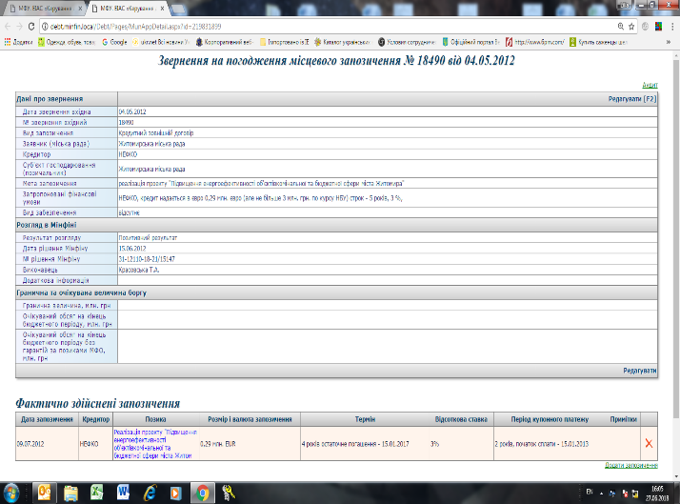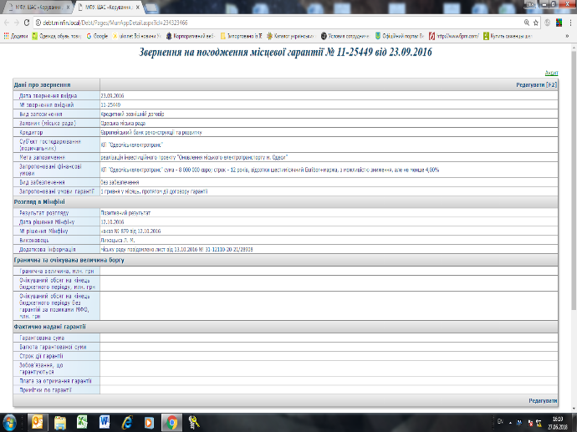

- Loans and guarantees registry (general info and cash flow data)
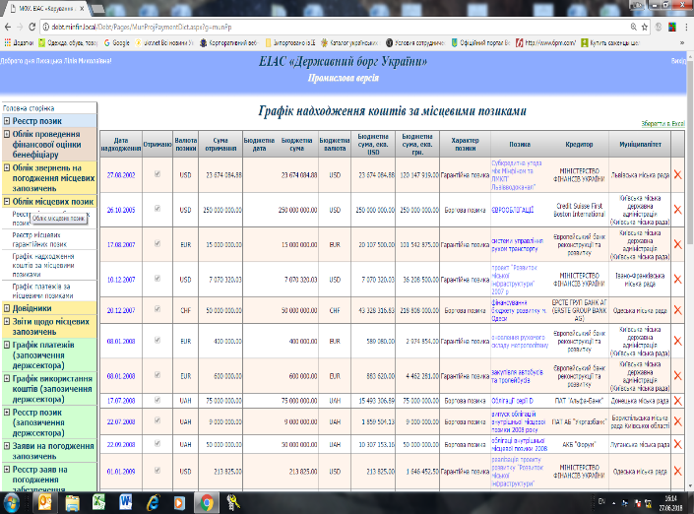

- Directories of municipalities and creditors
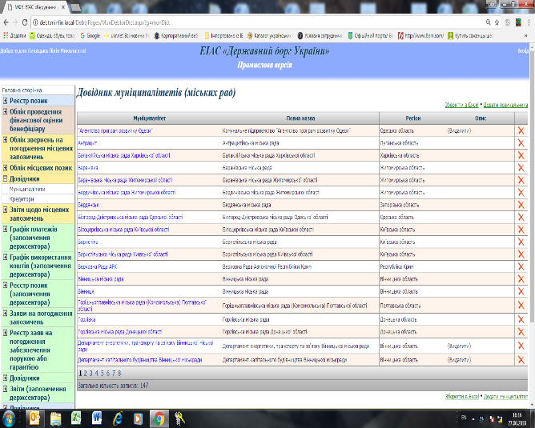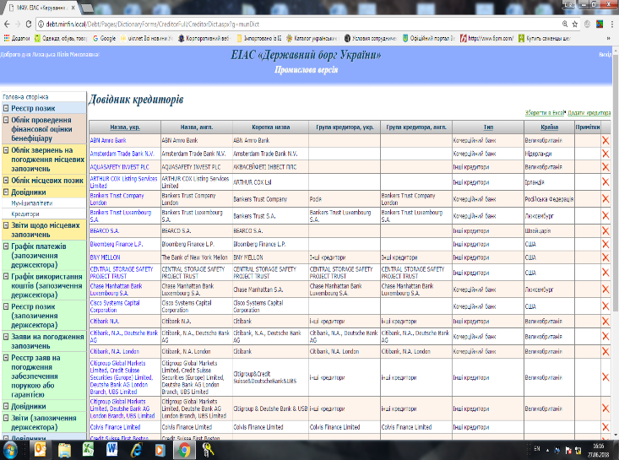

- Reporting module
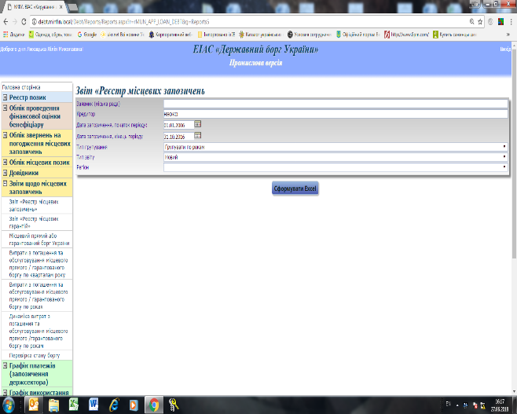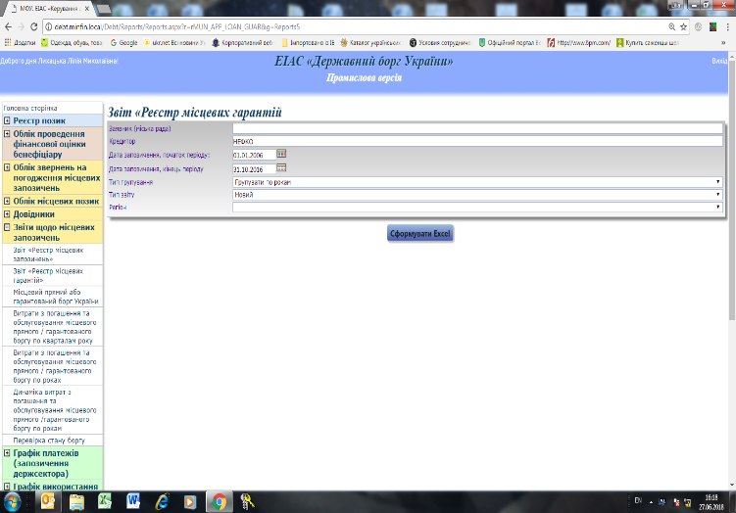

ANNEX 3

List of persons met:
Mr. Evgenii Kuzkin, Ministry of Finance, Assistant Minister, Head of Local Budgets Department
Ms. Olena Machulina, Ministry of Finance, Local Budgets Department
Ms. Polina Yarova, Ministry of Finance, Assistant Minister, Head of Debt Policy Department
Ms. Natalya Tolopilo, Ministry of Finance, Local Budgets Department
Ms. Lilia Lihatskaya, Ministry of Finance, Debt Policy Department
Ms. Natalia Bocman, Treasury, Deputy Head of Department for Methodology and Accounting of Local Budgets
Ms. Galina Babchenko, Treasury, Deputy Head of Consolidated Debt Department

In line with its decentralization agenda, in 2014, Ukraine has adopted the Law on Voluntary Amalgamation of Territorial communities which calls for association of villages into a higher-layer government units equal to the status of districts and province-subordinated cities.
According to the Article 73 of the Budget Code, all subnational governments can take internal debt obligations when the purpose of incurring such obligation is to bridge a liquidity gap that is a result of temporary timing mismatch of revenues and expenditures.
For reference please see the 2017 Public Finance Review prepared by the World Bank
Poland had a limit of 10 percent on debt service from 1994 until 1998. It was in 1998 when they lifted up this limit to the level of 15 percent.
As a part of its decentralization agenda, the central government introduced a new system of transfers to SNGs in 2015. The system now includes five different transfers of which three are earmarked for education, health and “training of civil servants”. Fourth transfer is given with an objective to fill the gap between what is needed for efficient service delivery at sub-national level and revenues realized by that particular SNGs. Fifth transfer is intended to counterweight the reduction in revenues of certain SNGs under the new system – its colloquial name is stabilization grant.
The format and structure of data provided under points 1 and 2 is prescribed by the Instruction number 922.
Recalculated using the exchange rate from July 30th, 2018
A well known domestic capital market development indicator “domestic credit to private sector” available from the WDI database, dropped from 78.1 percent in 2010 to as low as 31.3 percent in 2017.

